Module Name: Login Page
Test Case ID: 183
Webpage URL: https://practicetestautomation.com/

● Scenario ID: 2a
Scenario: Sign up with valid credentials
Test Steps:
1. Open login page
2. Enter Username
3. Enter Password
4. Click on Submit
Screenshots:

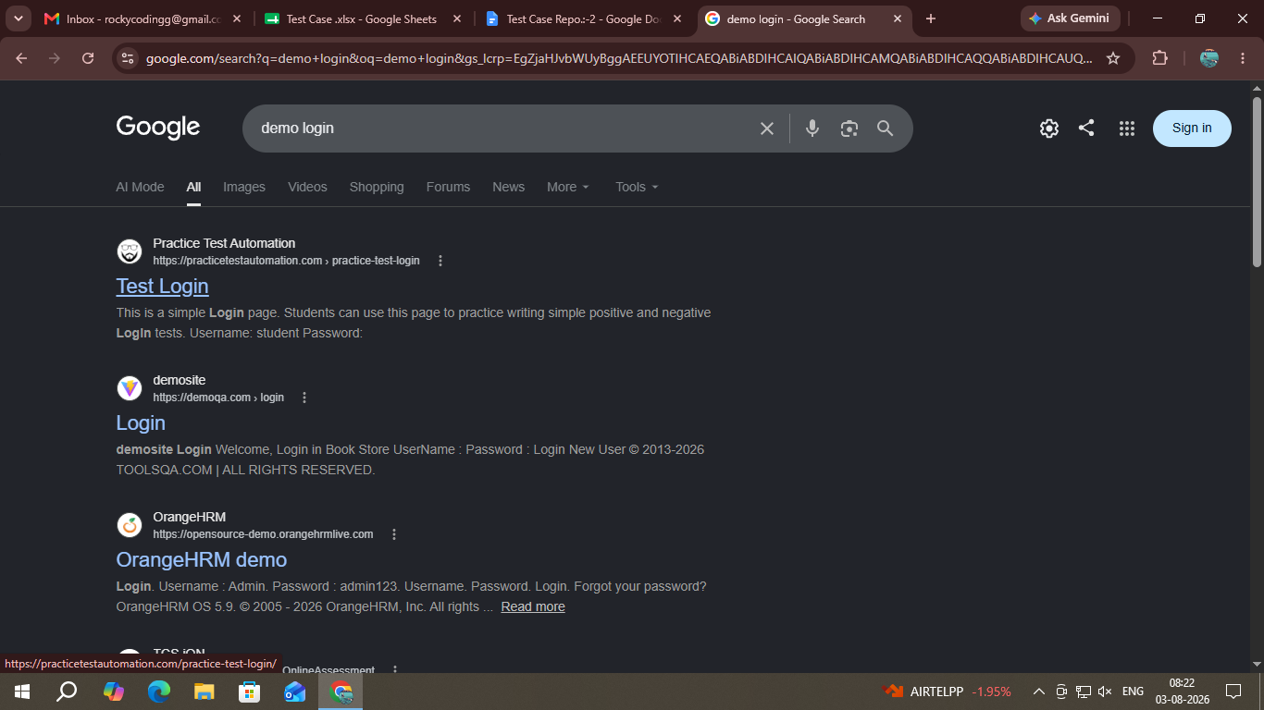
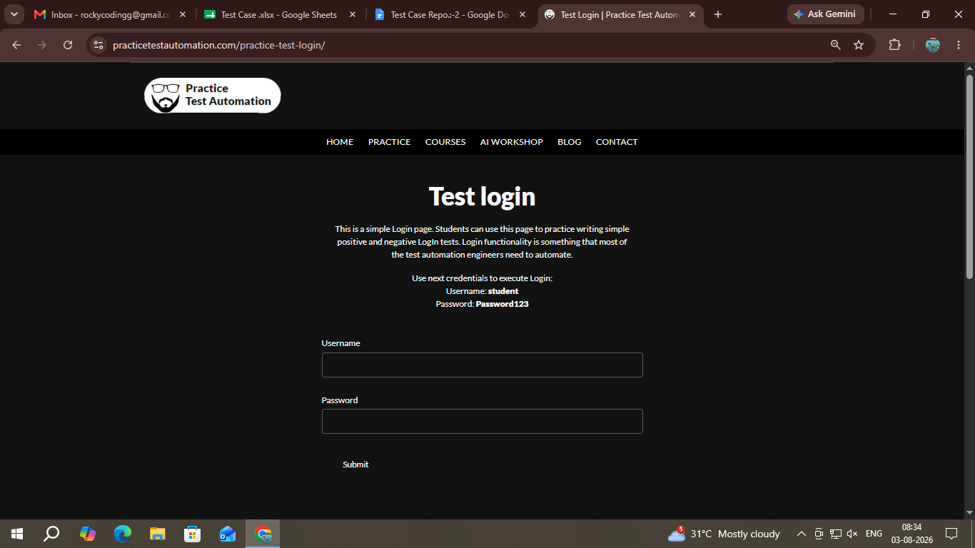
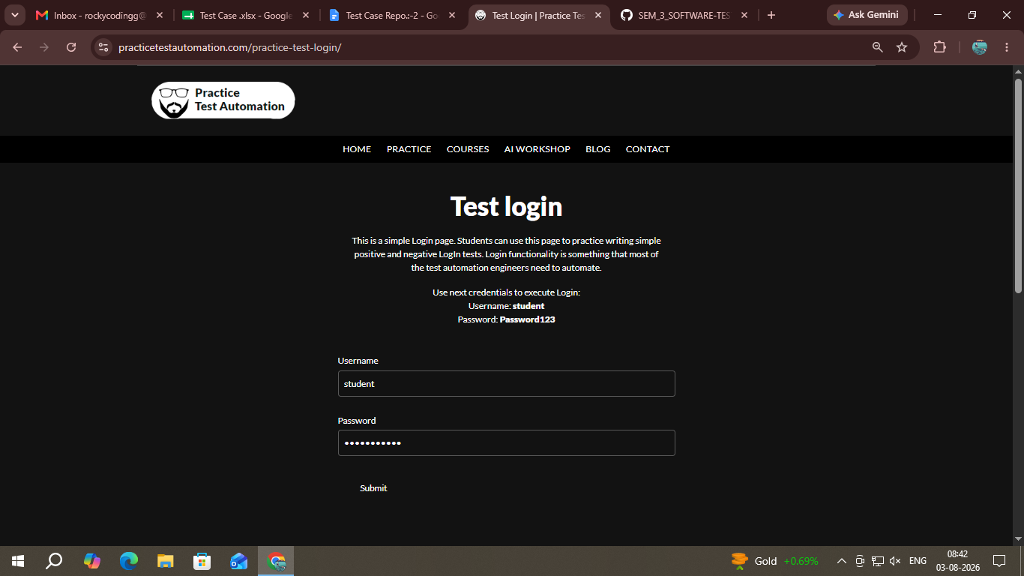
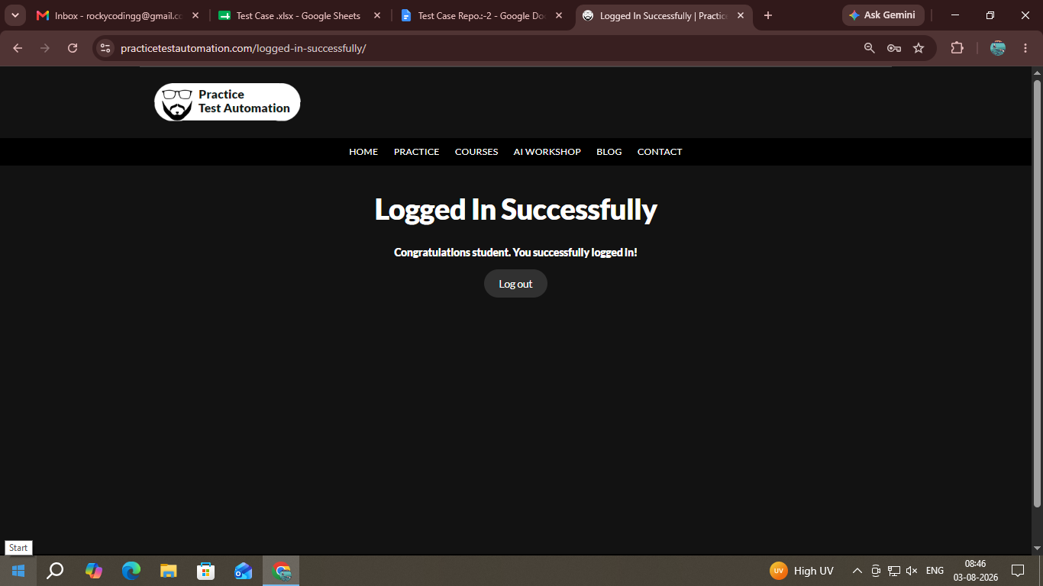

● Scenario ID: 2b

Scenerio: Login with invalid Username
Test Steps:

1. Open Login Page
2. Invalid Username
3. Valid Password
4. Login

Screenshots:
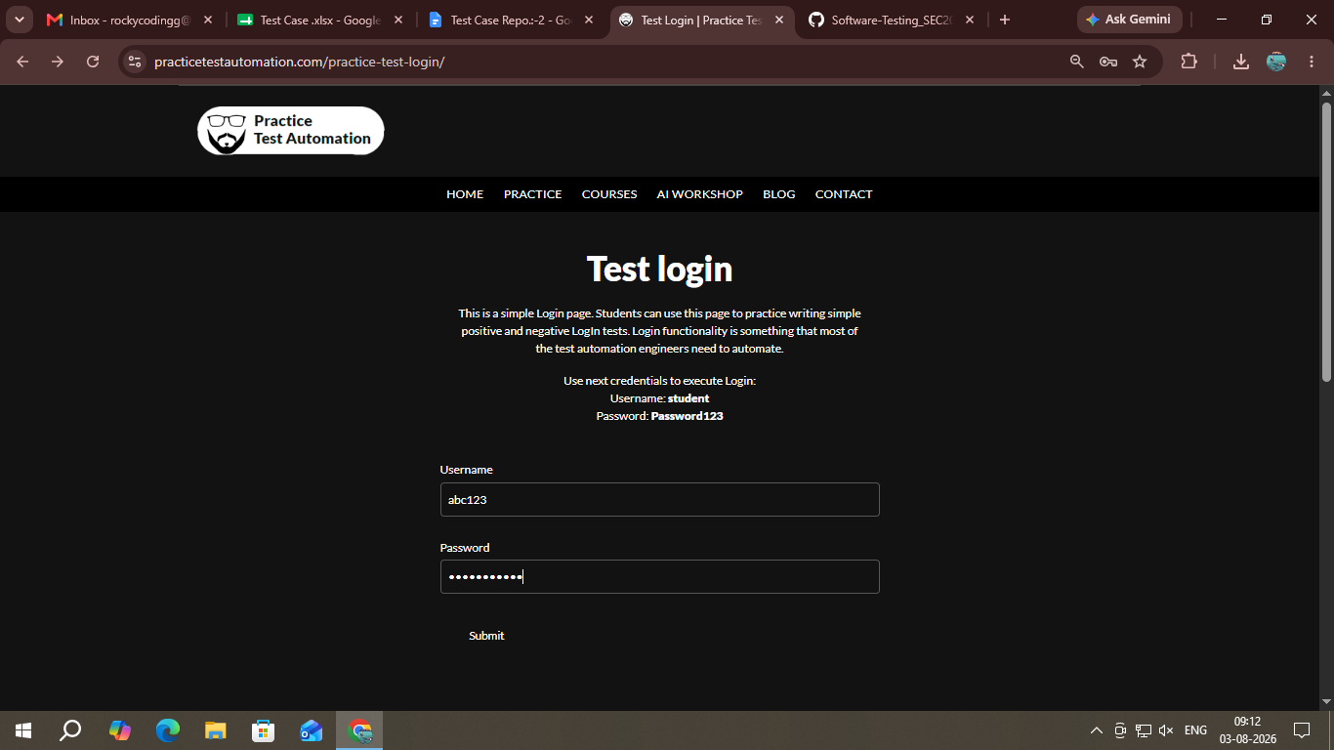
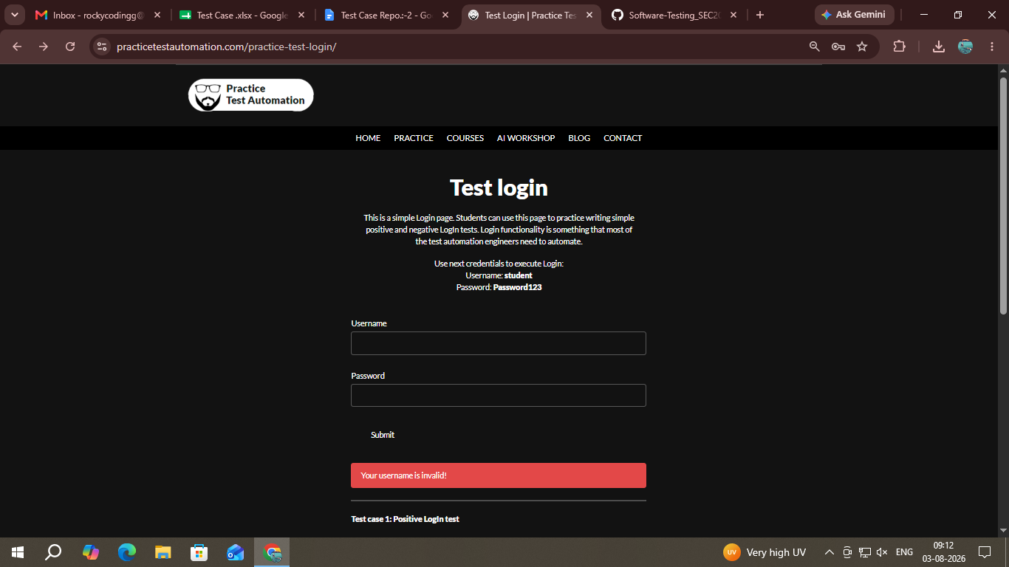

● Scenario ID: 2c

Scenerio: Login with invalid Password
Test Steps:▪
- Open Login Page
- Invalid Username
- Valid Password
- Login

Screenshots: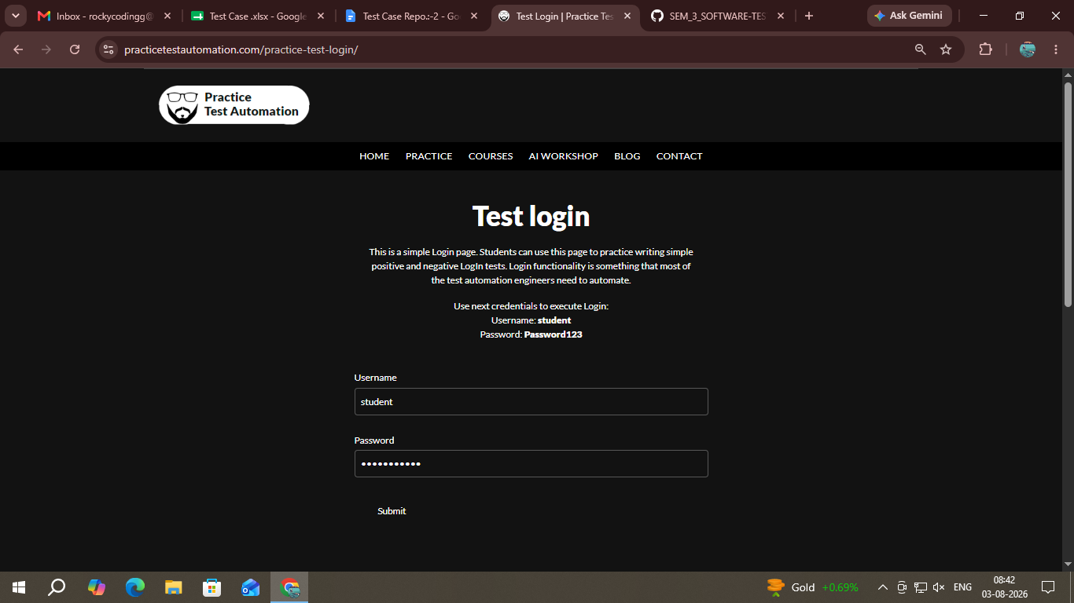

● Scenario ID: 2d

Scenerio: Login with empty Username
Test Steps:▪
- Open Login Page
- Leave Username Blank
- Valid Password
- Click Login

Screenshots:
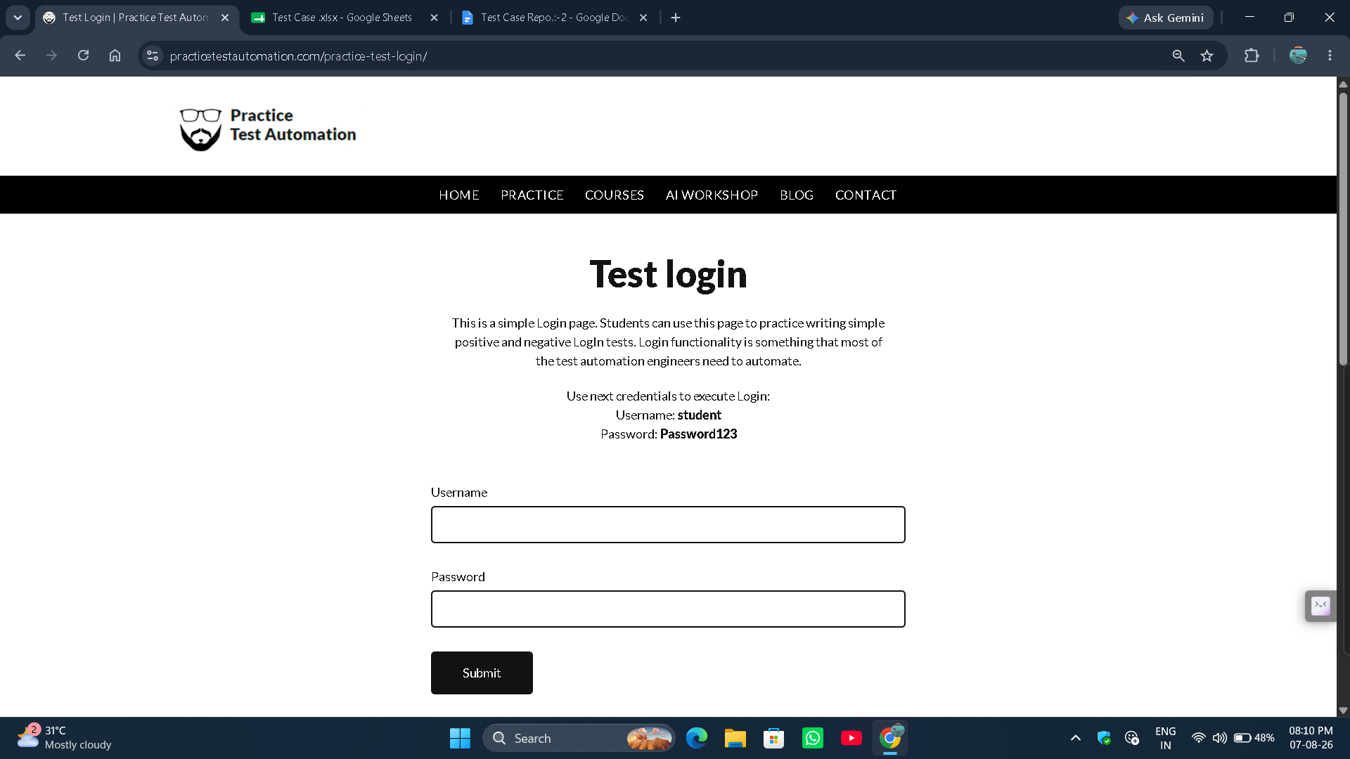

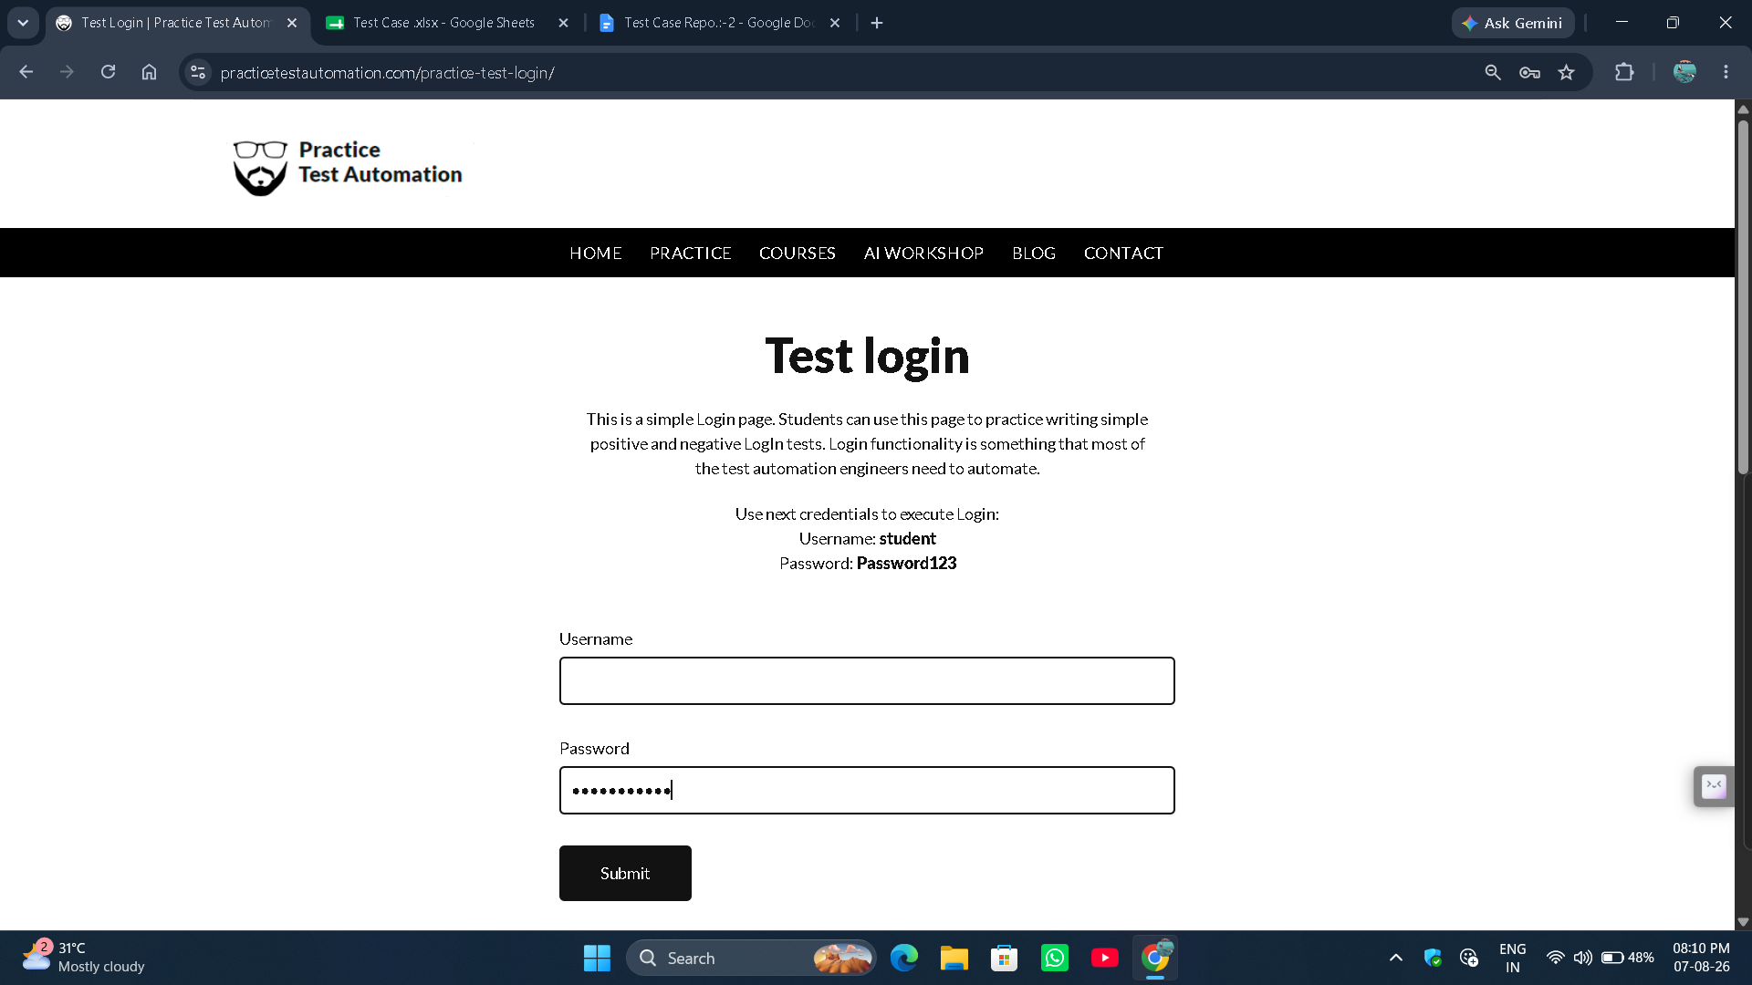
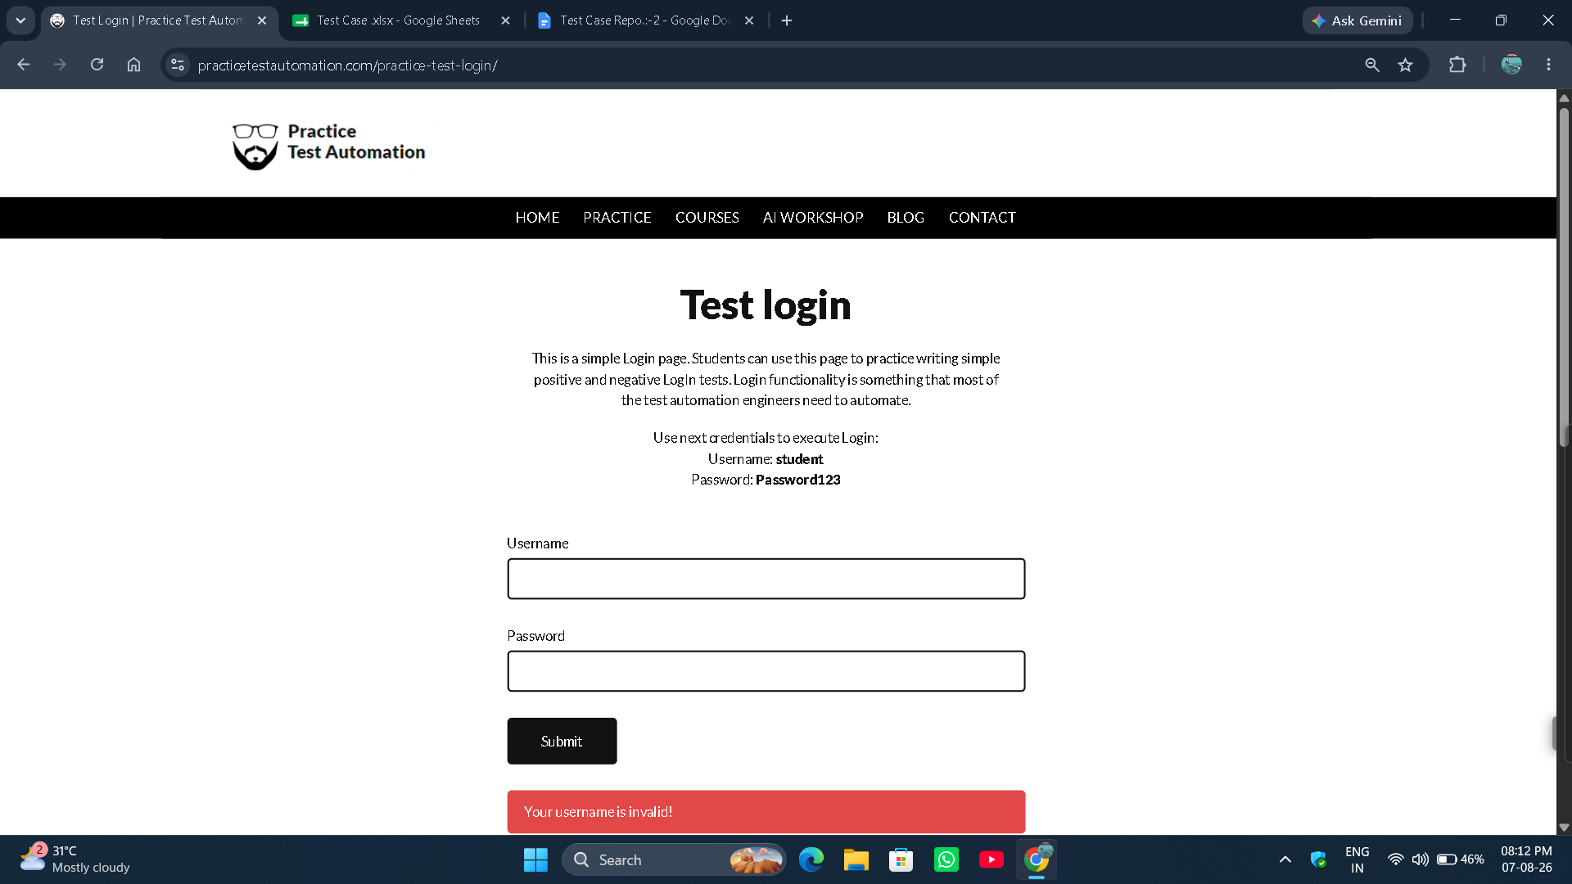

● Scenario ID: 2e

Scenerio: Login with empty Password
Test Steps:▪
- Open Login Page
- Valid Username
- Leave Password Blank
- Click Login

Screenshots: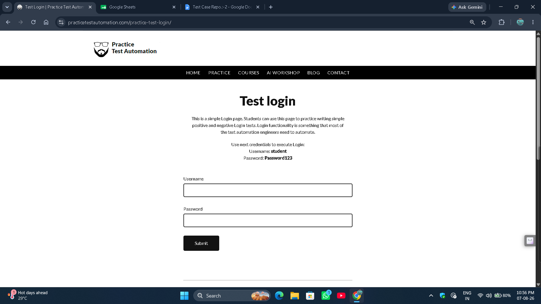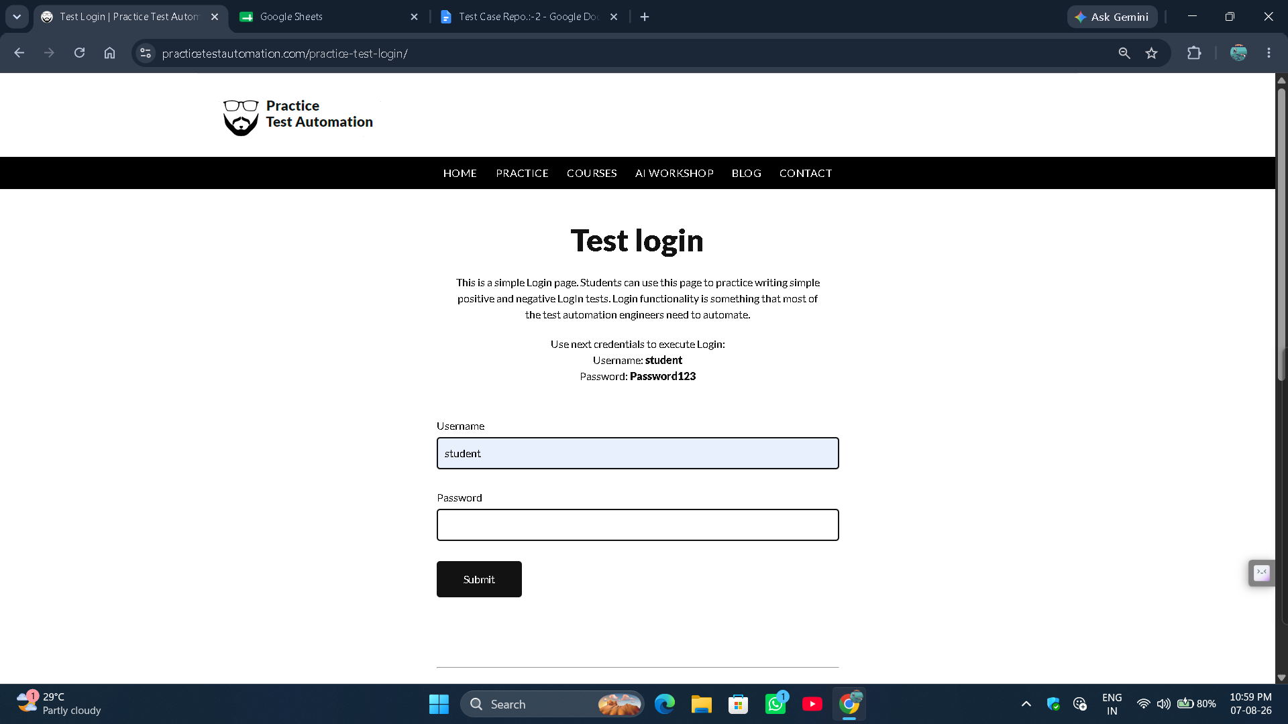

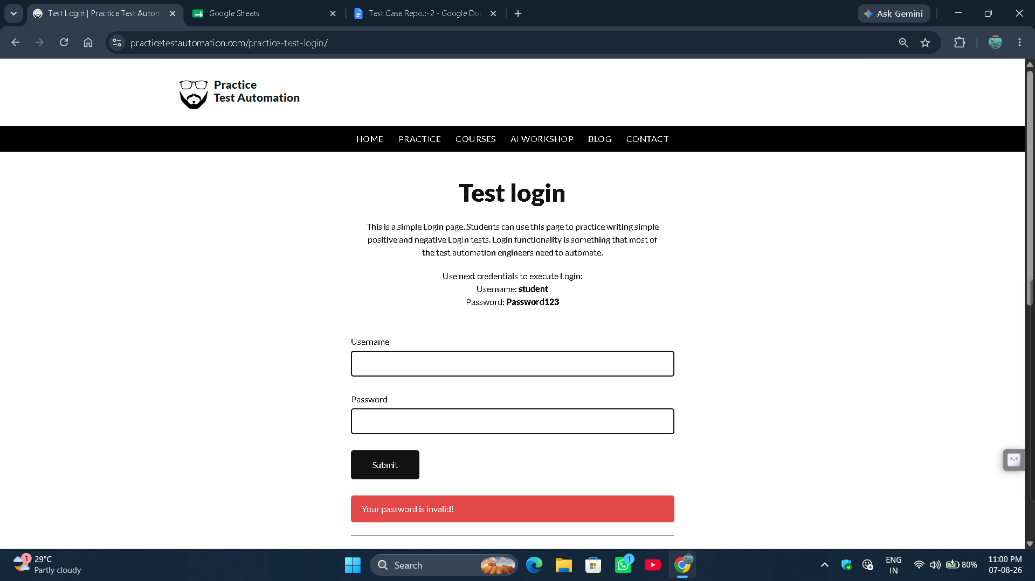

Scenario ID: 2f

Scenerio: Login with empty Username & Password
Test Steps:▪
- Open Login Page
- Leave Username Blank
- Leave Password Blank
- Click Login

Screenshots: